**MOBILE COMPUTING**

**Third Sem.**

**M.Sc. Computer Science**

**Unit - I**

**Shivaji Science College , Nagpur**

|  |
| --- |

**Unit-1**

**Introduction to Mobile Computing**

The rapidly expanding technology of cellular communication, wireless LANs, and satellite serviceswill make information accessible anywhere and atany time.Regardless of size, most mobile computers will be equipped with a wireless connection to the fixed part of the network, and, perhaps, to other mobile computers. The resulting computing environment, which is often referred to as ***mobile or nomadic computing***, no longer requires users to maintain a fixed and universally known position in the network and enables almost unrestricted mobility. Mobility and portability will create an entire new class

of applications and, possibly, consumer electronics.

new massive markets combining personal computing and

 **Mobile Computing** is an umbrella term used to describe technologies thatenable people to access network services anyplace, anytime, and anywhere.

A communication device can exhibit any one of the following characteristics: ➢ **Fixed and wired**: This configuration describes the typical desktop computerin an office. Neither weight nor power consumption of the devices allow for mobile usage. The devices use fixed networks for performance reasons.

➢ **Mobile and wired**: Many of today’s laptops fall into this category; users carry the laptop from one hotel to the next, reconnecting to the company’s network via thetelephone network and amodem.

➢ **Fixed and wireless**: This mode is used for installing networks, e.g., in historical buildings to avoid damage by installing wires, or at trade shows to ensure fast networksetup.

➢ **Mobile and wireless**: This is the most interesting case. No cable restricts the user, who canroambetweendifferentwirelessnetworks.Mosttechnologiesdiscussedinthisbook dealwiththis typeofdevice andthenetworks supporting them.Today’smost successful example for this category is GSM with more than 800 million users.

**APPLICATIONS OF MOBILE COMPUTING**

In many fields of work, the ability to keep on the move is vital in order to utilise time efficiently. The importance of Mobile Computers has been highlighted in many fields of which a few are described below:

a. **Vehicles:** Music, news, road conditions, weather reports, and other broadcast information are received via digital audio broadcasting (DAB) with 1.5 Mbit/s. For personal communication, a universal mobile telecommunications system (UMTS) phone might be available offering voice and data connectivity with 384 kbit/s. The current position of the car is determined via the global positioning system (GPS). Cars driving in the same area build a local ad-hoc network for the fast exchange of information in emergency situations or to help each other keep a safe distance. In case of an accident, not only will the airbag be triggered, but the police and ambulance service will be informed via an emergency call to a service provider. Buses, trucks, and trains are already transmitting maintenance and logistic information to their home base, which helps to improve organization (fleet management), and saves time and money.

b. **Emergencies**: An ambulance with a high-quality wireless connection to a hospital can carry vital information about injured persons to the hospital from the scene of the accident. All the necessary steps for this particular type of accident can be prepared and specialists can be consulted for an early diagnosis. Wireless networks are the only means

of communication in the case of natural disasters such as hurricanes or earthquakes. In the worst cases, only decentralized, wireless ad-hoc networks survive.

c. **Business**: Managers can use mobile computers say, critical presentations to major customers. They can access the latest market share information. At a small recess, they can revise the presentation to take advantage of this information. They can communicate with the office about possible new offers and call meetings for discussing responds to the new proposals. Therefore, mobile computers can leverage competitive advantages. A travelling salesman today needs instant access to the company’s database: to ensure that files on his or her laptop reflect the current situation, to enable the company to keep track of all activities of their travelling employees, to keep databases consistent etc. With wireless access, the laptop can be turned into a true mobile office, but efficient and powerful synchronization mechanisms are needed to ensure data consistency.

d. **Credit Card Verification**: At Point of Sale (POS) terminals in shops and supermarkets, when customers use credit cards for transactions, the intercommunication required between the bank central computer and the POS terminal, in order to effect verification of the card usage, can take place quickly and securely over cellular channels using a mobile computer unit. This can speed up the transaction process and relieve congestion at the POS terminals.

e. **Replacement of Wired Networks**: wireless networks can also be used to replace wired networks, e.g., remote sensors, for tradeshows, or in historic buildings. Due to economic reasons, it is often impossible to wire remote sensors for weather forecasts, earthquake detection, or to provide environmental information. Wireless connections, e.g., via satellite, can help in this situation. Other examples for wireless networks are computers, sensors, or information displays in historical buildings, where excess cabling may destroy valuable walls or floors.

f. **Infotainment**: wireless networks can provide up-to-date information at any appropriate location. The travel guide might tell you something about the history of a building (knowing via GPS, contact to a local base station, or triangulation where you are)

downloading information about a concert in the building at the same evening via a local wireless network. Another growing field of wireless network applications lies in entertainment and games to enable, e.g., ad-hoc gaming networks as soon as people meet to play together.

Limitations of Mobile Computing

▪ Resource constraints: Battery

▪ Interference: Radio transmission cannot be protected against interference using shielding and result in higher loss rates for transmitted data or higher bit error rates respectively

▪ Bandwidth: Although they are continuously increasing, transmission rates are still very low for wireless devices compared to desktop systems. Researchers look for more efficient communication protocols with low overhead.

▪ Dynamic changes in communication environment: variations in signal power within a region, thus link delays and connection losses

▪ Network Issues: discovery of the connection-service to destination and connection stability

▪ Interoperability issues: the varying protocol standards

▪ Security constraints: Not only can portable devices be stolen more easily, but the radio interface is also prone to the dangers of eavesdropping. Wireless access must always include encryption, authentication, and other security mechanisms that must be efficient and simple to use.

A simplified reference model

The figure shows the **protocol stack** implemented in the system according to the reference model. **End-systems**, such as the PDA and computer in the example, need a full protocol stack comprising the application layer, transport layer, network layer, data link layer, and physical layer. Applications on the end-systems communicate with each other using the lower layer services. **Intermediate systems**, such as the interworking unit, do not necessarily need all of the layers.

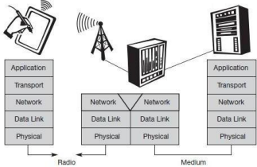**A Simplified Reference Model**

● **Physical layer**: This is the lowest layer in a communication system and is responsible for the conversion of a stream of bits into signals that can be transmitted on the sender side. The physical layer of the receiver then transforms the signals back into a bit stream. For wireless communication, the physical layer is responsible for frequency selection, generation of the carrier frequency, signal detection (although heavy interference may disturb the signal), modulation of data onto a carrier frequency and (depending on the transmission scheme) encryption.

● **Data link layer**: The main tasks of this layer include accessing the medium, multiplexing of different data streams, correction of transmission errors, and synchronization (i.e., detection of a data frame). Altogether, the data link layer is responsible for a reliable point to-point connection between two devices or a point-to-multipoint connection between one sender and several receivers.

● **Network layer**: This third layer is responsible for routing packets through a network or establishing a connection between two entities over many other intermediate systems. Important functions are addressing, routing, device location, and handover between different networks.

● **Transport layer**: This layer is used in the reference model to establish an end-to-end connection

● **Application layer**: Finally, the applications (complemented by additional layers that can support applications) are situated on top of all transmission oriented layers. Functions are service location, support for multimedia applications, adaptive applications that can handle the large variations in transmission characteristics, and wireless access to the world-wide web using a portable device.

**GSM : Mobile services, System architecture, Radio interface, Protocols, Localization and calling, Handover, Security, and New data services**.

**GSM Services**

GSM is the most successful digital mobile telecommunication system in the world today. It is used by over 800 million people in more than 190 countries. GSM permits the integration of different voice and data services and the interworking with existing networks. Services make a network interesting for customers. GSM has defined three different categories of services: **bearer, tele** and **supplementary services**.

***Bearer services***: GSM specifies different mechanisms for data transmission, the original GSM allowing for data rates of up to 9600 bit/s for non-voice services. Bearer services permit transparent and non-transparent, synchronous or asynchronous data transmission. **Transparent bearer services** only use the functions of the physical layer (layer 1) to transmit data. Datatransmissionhas aconstant delayandthroughput ifnotransmissionerrors occur. Transmission quality can be improved with the use of **forward error correction (FEC)**, which codes redundancy into the data stream and helps to reconstruct the original data in case of transmission errors. Transparent bearer services do not try to recover lost

data in case of, for example, shadowing or interruptions due to handover. **Non-transparent bearer services** use protocols of layers two and three to implement error correction and flow control. These services use the transparent bearer services, adding a **radio link protocol (RLP)**. This protocol comprises mechanisms of **high-level data link control (HDLC)**, and special selective-reject mechanisms to trigger retransmission of erroneous data.Using transparent and non-transparent services, GSM specifies several bearer services for interworking with PSTN, ISDN, and packet switched public data networks (PSPDN) like X.25, which is available worldwide. Data transmission can be full-duplex, synchronous with data rates of 1.2, 2.4, 4.8, and 9.6 kbit/s or full-duplex, asynchronous from 300 to 9,600 bit/s.

**Tele services**: GSM mainly focuses on voice-oriented tele services. These comprise encrypted voice transmission, message services, and basic data communication with terminals as known from the PSTN or ISDN (e.g., fax). The primary goal of GSM was the provision of high-quality digital voice transmission. Special codecs (coder/decoder) are used for voice transmission, while other codecs are used for the transmission of analog data for communication with traditional computer modems used in, e.g., fax machines. Another service offered by GSM is the **emergency number** (eg 911, 999). This service is mandatory for all providers and free of charge. This connection also has the highest priority, possibly pre-empting other connections, and will automatically be set up with the closest emergency center. A useful service for very simple message transfer is the **short message service (SMS)**, which offers transmission of messages of up to 160 characters. Sending and receiving of SMS is possible during data or voice transmission. It can be used for “serious” applications such as displaying road conditions, e-mail headers or stock quotes, but it can also transfer logos, ring tones, horoscopes and love letters.

The successor of SMS, the **enhanced message service (EMS)**, offers a larger

message size, formatted text, and the transmission of animated pictures, small images and ring tones in a standardized way. But with MMS, EMS was hardly used. MMS offers the transmission of larger pictures (GIF, JPG, WBMP), short video clips etc. and comes with mobile phones that integrate small cameras. Another non-voice tele service is **group 3 fax**, which is available worldwide. In this service, fax data is transmitted as digital data over the analog telephone network according to the ITU-T standards T.4 and T.30 usingmodems.

**Supplementary services**: In addition to tele and bearer services, GSM providers can offer **supplementary services**. these services offer various enhancements for the standard telephony service, and may vary from provider to provider. Typical services are user **identification**, call **redirection**, or **forwarding** of ongoing calls, barring of incoming/outgoing calls, Advice of Charge (AoC) etc. Standard ISDN features such as **closed user groups** and **multiparty** communication may be available.

GSM Architecture

A GSM system consists of three subsystems, the radio sub system (RSS), the network and switching subsystem (NSS), and the operation subsystem (OSS).

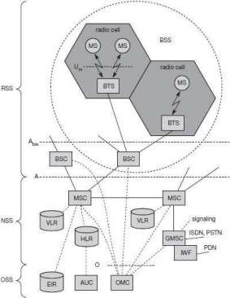

**Functional Architecture of a GSM System**

***Network Switching Subsystem***: The NSS is responsible for performing callprocessing and subscriber related functions. The switching system includes the following functional units:

➢ Home location register (HLR): It is a database used for storage and management of

subscriptions. HLR stores permanent data about subscribers, including a subscribers service profile, location information and activity status. When an individual buys a subscription from the PCS provider, he or she is registered in the HLR of that operator.

➢ Visitor location register (VLR): It is a database that contains temporary information about subscribers that is needed by the MSC in order to service visiting subscribers. VLR is always integrated with the MSC. When a MS roams into a new MSC area, the VLR connected to that MSC will request data about the mobile station from the HLR. Later if the mobile station needs to make a call, VLR will be having all the information needed for call setup.

➢ Authentication center (AUC): A unit called the AUC provides authentication and encryption parameters that verify the users identity and ensure the confidentiality of each call.

➢ Equipment identity register (EIR): It is a database that contains information about the identity of mobile equipment that prevents calls from stolen, unauthorized or defective mobile stations.

➢ Mobile switching center (MSC): The MSC performs the telephony switching functions of the system. It controls calls to and from other telephone and data systems.

***Radio Subsystem (RSS)***: the **radio subsystem (RSS)** comprises all radio specific entities, i.e., the **mobile stations (MS)** and the **base station subsystem (BSS)**. The figure shows the connection between the RSS and the NSS via the **A interface** (solid lines) and the connection to the OSS via the **O interface** (dashed lines).

➢ Base station subsystem (BSS): A GSM network comprises many BSSs, each controlled by a base station controller (BSC). The BSS performs all functions necessary to maintain radio connections to an MS, coding/decoding of voice, and rate adaptation to/from the wireless network part. Besides a BSC, the BSS contains several BTSs.

➢ Base station controllers (BSC): The BSC provides all the control functions and physical links between the MSC and BTS. It is a high capacity switch that provides functions such as handover, cell configuration data, and control of radio frequency (RF) power levels in BTS. A number of BSC’s are served by and MSC.

➢ Base transceiver station (BTS): The BTS handles the radio interface to the mobile station. A BTS can form a radio cell or, using sectorized antennas, several and is connected to MS via the **Um interface**, and to the BSC via the **Abis interface**. The Um interface contains all the mechanisms necessary for wireless transmission (TDMA, FDMA etc.)The BTS is the radio equipment (transceivers and antennas) needed to service each cell in the network. A group of BTS’s are controlled by an BSC.

***Operation and Support system***: The operations and maintenance center (OMC) is connected to all equipment in the switching system and to the BSC. Implementation of OMC is called operation and support system (OSS). The OSS is the functional entity from which the network operator monitors and controls the system. The purpose of OSS is to offer the customer cost-effective support for centralized, regional and local operational and maintenance activities that are required for a GSM network. OSS provides a network overview and allows engineers to monitor, diagnose and troubleshoot every aspect of the GSM network.

The mobile station (MS) consists of the mobile equipment (the terminal) and a smart card called the Subscriber Identity Module (SIM). The SIM provides personal mobility, so that the user can have access to subscribed services irrespective of a specific terminal. By inserting the SIM card into another GSM terminal, the user is able to receive calls at that terminal, make calls from that terminal, and receive other subscribed services.

The mobile equipment is uniquely identified by the International Mobile Equipment Identity (IMEI). The SIM card contains the International Mobile Subscriber Identity (IMSI) used to identify the subscriber to the system, a secret key for authentication, and other information. The IMEI and the IMSI are independent, thereby allowing personal mobility. The SIM card may be protected against unauthorized use by a password or personal identity number.

**Radio Interface**

The most interesting interface in a GSM system is Um, the radio interface, as it comprises various multiplexing and media access mechanisms. GSM implements SDMA using cells with BTS and assigns an MS to a BTS.

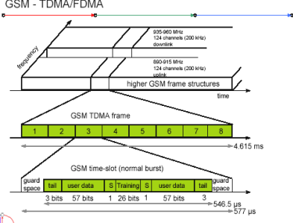**GSM TDMA Frame, Slots and Bursts**

Each of the 248 channels is additionally separated in time via a **GSM TDMA frame**, i.e., each 200 kHz carrier is subdivided into frames that are repeated continuously. The duration of a frame is 4.615 ms. A frame is again subdivided into 8 **GSM time slots**, where each slot represents a physical TDM channel and lasts for 577 *µ*s. Each TDM channel occupies the 200 kHz carrier for 577 *µ*s every 4.615 ms. Data is transmitted in small portions, called **bursts**. The following figure shows a so called **normal burst** as used for data transmission inside a time slot. As shown, the burst is only 546.5 *µ*s long and contains 148 bits. The remaining 30.5 *µ*s are used as **guard space** to avoid overlapping with other bursts due to different path delays and to give the transmitter time to turn on and off.

The first and last three bits of a normal burst (**tail**) are all set to 0 and can be used to enhance the receiver performance. The **training** sequence in the middle of a slot is used to adapt the parameters of the receiver to the current path propagation characteristics and to select the strongest signal in case of multi-path propagation. A flag **S** indicates whether the **data** field contains user or network control data.

Apart from the normal burst, ETSI (1993a) defines four more bursts for data transmission: a **frequency correction** burst allows the MS to correct the local oscillator to avoid interference with neighbouring channels, a **synchronization burst** with an extended training sequence synchronizes the MS with the BTS in time, an **access burst** is used for the initial connection setup between MS and BTS, and finally a **dummy burst** is used if no data is available for a slot.

**Logical channels and frame hierarchy**

Two types of channels, namely physical channels and logical channels are present. **Physical channel:** channel defined by specifying both, a carrier frequency and a TDMA timeslot number. **Logic channel:** logical channels are multiplexed into the physical channels. Each logic channel performs a specific task. Consequently the data of a logical channel is

transmitted in the corresponding timeslots of the physical channel. During this process, logical channels can occupy a part of the physical channel or even the entire channel.

Each of the frequency carriers is divided into frames of 8 timeslots of approximately 577 s (15/26 s) duration with 156.25 bits per timeslot. The duration of a TDMA frame is 4.615ms (577 s x 8 = 4.615 ms). The bits per timeslot and frame duration yield a gross bit rate of about 271kbps per TDMA frame.

TDMA frames are grouped into two types of multiframes:

• 26-frame multiframe (4.615ms x 26 = 120 ms) comprising of 26 TDMA frames. This multiframe is used to carry traffic channels and their associated control channels.

• 51-frame multiframe (4.615ms x 51 235.4 ms) comprising 51 TDMA frames. This multiframe is exclusively used for control channels.

The multiframe structure is further multiplexed into a single superframe of duration of 6.12sec. This means a superframe consists of

• 51 multiframes of 26 frames.

• 26 multiframes of 51 frames.

The last multiplexing level of the frame hierarchy, consisting of 2048 superframes (2715648 TDMA frames), is a hyperframe. This long time period is needed to support the GSM data encryption mechanisms. The frame hierarchy is shown below:

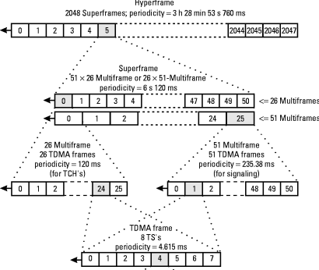**GSM Frame Hierarchy**

There are two different types of logical channel within the GSM system: Traffic channels (TCHs), Control channels (CCHs).

**Traffic Channels:** Traffic channels carry user information such as encoded speech or user data. Traffic channels are defined by using a 26-frame multiframe. Two general forms are defined:

*i.* Full rate traffic channels (TCH/F), at a gross bit rate of 22.8 kbps (456bits / 20ms) *ii.* Half rate traffic channels (TCH/H), at a gross bit rate of 11.4 kbps. Uplink and downlink are separated by three slots (bursts) in the 26-multiframe structure. This simplifies the duplexing function in mobile terminals design, as mobiles will not need to transmit and receive at the same time. The 26-frame multiframe structure, shown below multiplexes two types of logical channels, a TCH and a Slow Associated Control CHannel (SACCH).

However, if required, a Fast Associated Control CHannel (FACCH) can steal TCH in order to transmit control information at a higher bit rate. This is usually the case during the handover process. In total 24 TCH/F are transmitted and one SACCH.

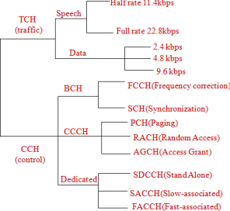

**Control Channels:** Control channels carry system signalling and synchronisation data for control procedures such as location registration, mobile station synchronisation, paging, random access etc. between base station and mobile station. Three categories of control channel are defined: Broadcast, Common and Dedicated. Control channels are multiplexed into the 51-frame multiframe.

➢ **Broadcast control channel (BCCH)**: A BTS uses this channel to signal information to all MSs within a cell. Information transmitted in this channel is, e.g., the cell identifier, options available within this cell (frequency hopping), and frequencies available inside the cell and in neighboring cells. The BTS sends information for frequency correction via the **frequency correction channel (FCCH)** and information about time synchronization via the **synchronization channel (SCH)**, where both channels are subchannels of the BCCH.

➢ **Common control channel (CCCH)**: All information regarding connection setup between MS and BS is exchanged via the CCCH. For calls toward an MS, the BTS uses the **paging channel (PCH)** for paging the appropriate MS. If an MS wants to set up a call, it uses the **random access channel (RACH)** to send data to the BTS. The RACH implements multiple access (all MSs within a cell may access this channel) using slotted Aloha. This is where a collision may occur with other MSs in a GSM system. The BTS uses the **access grant channel (AGCH)** to signal an MS that it can use a TCH or SDCCH for further connection setup.

➢ **Dedicated control channel (DCCH)**: While the previous channels have all been unidirectional, the following channels are bidirectional. As long as an MS has not established a TCH with the BTS, it uses the **stand-alone dedicated control channel (SDCCH)** with a low data rate (782 bit/s) for signaling. This can comprise authentication, registration or other data needed for setting up a TCH. Each TCH and SDCCH has a **slow associated dedicated control channel (SACCH)** associated with it, which is used to exchange system information, such as the channel quality and signal power level. Finally, if more signaling information needs to be transmitted and a TCH already exists, GSM uses a **fast associated dedicated control channel (FACCH)**. The FACCH uses the time slots which are otherwise used by the TCH. This is necessary in the case of handovers where BTS and MS have to exchange larger amounts of data in less time.

**GSM Protocols**

The signalling protocol in GSM is structured into three general layers depending on the interface, as shown below. Layer 1 is the physical layer that handles all **radio**-specific functions. This includes the creation of bursts according to the five different formats, **multiplexing** of bursts into a TDMA frame, **synchronization** with the BTS, detection of idle channels, and measurement of the **channel qualit**y on the downlink. The physical layer at Um uses GMSK for digital **modulation** and performs **encryption/decryption** of data, i.e., encryption is not performed end-to-end, but only between MS and BSS over the air interface.

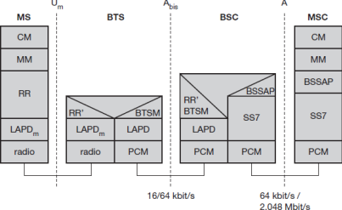**Protocol architecture for Signaling**

The main tasks of the physical layer comprise **channel coding** and **error detection/correction**, which is directly combined with the coding mechanisms. Channel coding makes extensive use of different **forward error correction (FEC)** schemes. Signaling between entities in a GSM network requires higher layers. For this purpose, the **LAPDm** protocol has been defined at the Um interface for **layer two**. LAPDm has been derived from link access procedure for the D-channel (**LAPD**) in ISDN systems, which is a version of HDLC. LAPDm is a lightweight LAPD because it does not need synchronization flags or checksumming for error detection. LAPDm offers reliable data transfer over connections, re- sequencing of data frames, and flow control.

The network layer in GSM, layer three, comprises several sublayers. The lowest sublayer is the radio resource management (RR). Only a part of this layer, RR’, is implemented in the BTS, the remainder is situated in the BSC. The functions of RR’ are supported by the BSC via the BTS management (BTSM). The main tasks of RR are setup, maintenance, and release of radio channels. Mobility management (MM) contains functions for registration, authentication, identification, location updating, and the provision of a temporary mobile subscriber identity (TMSI).

Finally, the call management (CM) layer contains three entities: call control (CC), short message service (SMS), and supplementary service (SS). SMS allows for message transfer using the control channels SDCCH and SACCH, while SS offers the services like user identification, call redirection, or forwarding of ongoing calls. CC provides a point- to

point

connection between two terminals and is used by higher layers for call establishment, call clearing and change of call parameters. This layer also provides functions to send in-band tones, called dual tone multiple frequency (DTMF), over the GSM network. These tones are used, e.g., for the remote control of answering machines or the entry of PINs in electronic banking and are, also used for dialing in traditional analog telephone systems.

Additional protocols are used at the Abis and A interfaces. Data transmission at the physical layer typically uses **pulse code modulation (PCM)** systems. LAPD is used for layer two at Abis, BTSM for BTS management. **Signaling system No. 7 (SS7)** is used for signaling between an MSC and a BSC. This protocol also transfers all management information between MSCs, HLR, VLRs, AuC, EIR, and OMC. An MSC can also control a BSS via a **BSS application part (BSSAP)**.

**Localization and Calling**

The fundamental feature of the GSM system is the automatic, worldwide localization of users for which, the system performs periodic location updates. The HLR always contains information about the current location and the VLR currently responsible for the MS informs the HLR about the location changes. Changing VLRs with uninterrupted availability is called roaming. Roaming can take place within a network of one provider, between two providers in a country and also between different providers in different countries.

To locate and address an MS, several numbers are needed:

➢ **Mobile station international ISDN number (MSISDN)**:- The only important number for a user of GSM is the phone number. This number consists of the country code (CC), the national destination code (NDC) and the subscriber number (SN).

➢ **International mobile subscriber identity (IMSI)**: GSM uses the IMSI for internal unique identification of a subscriber. IMSI consists of a mobile country code (MCC), the mobile network code (MNC), and finally the mobile subscriber identification number (MSIN).

➢ **Temporary mobile subscriber identity (TMSI)**: To hide the IMSI, which would give away the exact identity of the user signalling over the air interface, GSM uses the 4 byte TMSI for local subscriberidentification.

➢ **Mobile station roaming number (MSRN)**: Another temporary address that hides the identity and location of a subscriber is MSRN. The VLR generates this address on request from the MSC, and the address is also stored in the HLR. MSRN contains the current visitor country code (VCC), the visitor national destination code (VNDC), the identification of the current MSC together with the subscriber number. The MSRN helps the HLR to find a subscriber for an incoming call.

For ***a mobile terminated call (MTC),*** the following figure shows the different steps that take place:

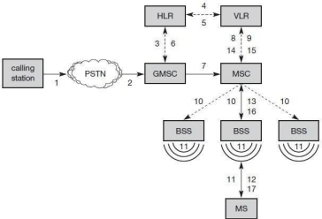**Mobile Terminated Call(MTC)**

**step 1:** User dials the phone number of a GSM subscriber.

**step 2:** The fixed network (PSTN) identifies the number belongs to a user in GSM network and forwards the call setup to the Gateway MSC (GMSC).

**step 3:** The GMSC identifies the HLR for the subscriber and signals the call setup to HLR **step 4:** The HLR checks for number existence and its subscribed services and requests an MSRN from the current VLR.

**step 5:** VLR sends the MSRN to HLR

**step 6:** Upon receiving MSRN, the HLR determines the MSC responsible for MS and forwards the information to the GMSC

**step 7:** The GMSC can now forward the call setup request to the MSC indicated **step 8:** The MSC requests the VLR for the current status of the MS

**step 9:** VLR sends the requested information

**step 10:** If MS is available, the MSC initiates paging in all cells it is responsible for. **step 11:** The BTSs of all BSSs transmit the paging signal to the MS

**step 12: Step 13**: If MS answers, VLR performs security checks

**step 15: Till step 17**: Then the VLR signals to the MSC to setup a connection to the MS

For a **mobile originated call (MOC),** the following steps take place:

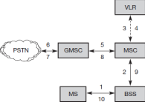

**step 1:** The MS transmits a request for a new connection

**step 2:** The BSS forwards this request to the MSC

**step 3: Step 4:** The MSC then checks if this user is allowed to set up a call with the requested and checks the availability of resources through the GSM network and into the PSTN. If all resources are available, the MSC sets up a connection between the MS and the fixed network.

In addition to the steps mentioned above, other messages are exchanged between an MS and BTS during connection setup (in either direction).

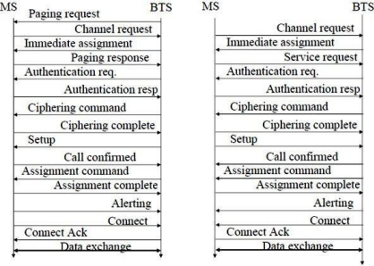**Message flow for MTC and MOC**

**Handover**

Cellular systems require **handover** procedures, as single cells do not cover the whole service area. However, a handover should not cause a cut-off, also called **call drop**. GSM aims at maximum handover duration of 60 ms. There are two basic reasons for a handover:

**1.** The mobile station **moves out of the range** of a BTS, decreasing the received **signal level** increasing the **error rate** thereby diminishing the **quality of the radio link. 2.** Handover may be due to **load balancing,** when an MSC/BSC decides the traffic is too high in one cell and shifts some MS to other cells with a lower load.

The four possible handover scenarios of GSM are shown below:

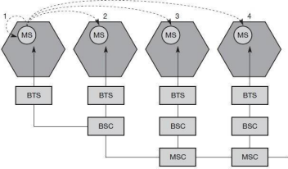➢ **Intra-cell handover:** Within a cell, narrow-band interference could make transmission

at a certain frequency impossible. The BSC could then decide to change the carrier frequency (scenario 1).

➢ **Inter-cell, intra-BSC handover:** This is a typical handover scenario. The mobile station moves from one cell to another, but stays within the control of the same BSC. The BSC then performs a handover, assigns a new radio channel in the new cell and releases the old one (scenario 2).

➢ **Inter-BSC, intra-MSC handover:** As a BSC only controls a limited number of cells; GSM also has to perform handovers between cells controlled by different BSCs. This handover then has to be controlled by the MSC (scenario 3).

➢ **Inter MSC handover:** A handover could be required between two cells belonging to different MSCs. Now both MSCs perform the handover together (scenario 4).

To provide all the necessary information for a handover due to a weak link, MS and BTS both perform periodic measurements of the downlink and uplink quality respectively. Measurement reports are sent by the MS about every half-second and contain the quality of the current link used for transmission as well as the quality of certain channels in neighboring cells (the BCCHs).

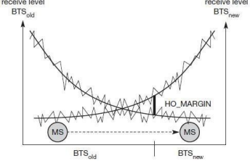**Handover decision depending on receive level**

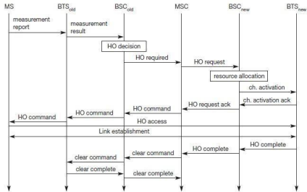**Intra-MSChandover**

More sophisticated handover mechanisms are needed for seamless handovers between different systems.

**Security**

GSM offers several security services using confidential information stored in the AuC and in the individual SIM. The SIM stores personal, secret data and is protected with a PIN against unauthorized use. Three algorithms have been specified to provide security services in GSM. **Algorithm A3** is used for **authentication**, **A5** for **encryption**, and **A8** for the **generation of a cipher key**. The various security services offered by GSM are:

**Access control and authentication:** The first step includes the authentication of a valid user for the SIM. The user needs a secret PIN to access the SIM. The next step is the subscriber authentication. This step is based on a challenge-response scheme as shown below:

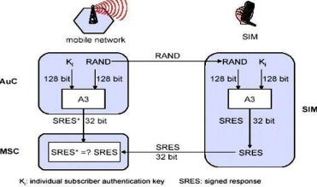**Subscriber Authentication**

Authentication is based on the SIM, which stores the **individual authentication key Ki**, the **user identification IMSI**, and the algorithm used for authentication **A3**. The AuC performs the basic generation of random values RAND, signed responses SRES, and cipher keys Kc for each IMSI, and then forwards this information to the HLR. The current VLR requests the appropriate values for RAND, SRES, and **Kc** from the HLR. For authentication, the VLR sends the random value RAND to the SIM. Both sides, network and subscriber module, perform the same operation with RAND and the key **Ki**, called **A3**. The MS sends back the SRES generated by the SIM; the VLR can now compare both values. If they are the same, the VLR accepts the subscriber, otherwise the subscriber is rejected.

**Confidentiality:** All user-related data is encrypted. After authentication, BTS and MS apply encryption to voice, data, and signalling as shown below.

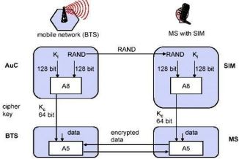To ensure privacy, all messages containing user-related information are encrypted in GSM over the air interface. After authentication, MS and BSS can start using encryption by applying the cipher key **Kc**, which is generated using the individual key Ki and a random value by applying the algorithm A8. Note that the SIM in the MS and the network both calculate the same **Kc** based on the random value RAND. The key Kc itself is not transmitted over the air interface. MS and BTS can now encrypt and decrypt data using the algorithm A5 and the cipher key Kc.

**Anonymity:** To provide user anonymity, all data is encrypted before transmission, and user identifiers are not used over the air. Instead, GSM transmits a temporary identifier (TMSI), which is newly assigned by the VLR after each location update. Additionally, the VLR can change the TMSI at any time.

**New Data Services**

To enhance the data transmission capabilities of GSM, two basic approaches are possible. As the basic GSM is based on connection-oriented traffic channels, e.g., with 9.6 kbit/s each, several channels could be combined to increase bandwidth. This system is called **HSCSD**

**{high speed circuit switched data}.** A more progressive step is the introduction of packet oriented traffic in GSM, i.e., shifting the paradigm from connections/telephone thinking to packets/internet thinking. The system is called **GPRS {general packet radio service}**.

**HSCD**: A straightforward improvement of GSM’s data transmission capabilities is high speed circuit switched data (HSCSD) in which higher data rates are achieved by bundling several TCHs. An MS requests one or more TCHs from the GSM network, i.e., it allocates several TDMA slots within a TDMA frame. This allocation can be asymmetrical, i.e. more slots can be allocated on the downlink than on the uplink, which fits the typical user behaviour of downloading more data compared to uploading. A major disadvantage of HSCD is that it still uses the connection-oriented mechanisms of GSM, which is not efficient for computer data traffic.

**GPRS**: The next step toward more flexible and powerful data transmission avoids the problems of HSCSD by being fully packet-oriented. The **general packet radio service (GPRS)** provides packet mode transfer for applications that exhibit traffic patterns such as frequent transmission of small volumes (e.g., typical web requests) or infrequent transmissions of small or medium volumes (e.g., typical web responses) according to the requirement specification. For the new GPRS radio channels, the GSM system can allocate between one and eight time slots within a TDMA frame. Time slots are not allocated in a fixed, pre-determined manner but on demand. All time slots can be shared by the active users; up- and downlink are allocated separately. Allocation of the slots is based on current load and operator preferences. The GPRS concept is independent of channel characteristics and of the type of channel (traditional GSM traffic or control channel), and does not limit the maximum data rate (only the GSM transport system limits the rate). All GPRS services can be used in parallel to conventional services. GPRS includes several **security services** such as authentication, access control, user identity confidentiality, and user information confidentiality.

The GPRS architecture introduces two new network elements, which are called GPRS support nodes (GSN) and are in fact routers. All GSNs are integrated into the standard GSM architecture, and many new interfaces have been defined. The gateway GPRS support node (GGSN) is the interworking unit between the GPRS network and external packet data networks (PDN). This node contains routing information for GPRS users, performs address conversion, and tunnels data to a user via encapsulation. The GGSN is connected to external networks (e.g., IP or X.25) via the Gi interface and transfers packets to the SGSN via an IP- based GPRS backbone network (Gn interface). The other new element is the **serving GPRS support node (SGSN)** which supports the MS via the Gb interface. The SGSN, for example, requests user addresses from the **GPRS register (GR)**, keeps track of the individual MSs’ location, is responsible for collecting billing information (e.g., counting bytes), and performs several security functions such as access control. The SGSN is connected to a BSC via frame

relay and is basically on the same hierarchy level as an MSC. The GR, which is typically a part of the HLR, stores all GPRS-relevant data.

**GPRS Architecture Reference Model**

As shown above, packet data is transmitted from a PDN, via the GGSN and SGSN directly to the BSS and finally to the MS. The MSC, which is responsible for data transport in the traditional circuit-switched GSM, is only used for signalling in the GPRS scenario. Before sending any data over the GPRS network, an MS must attach to it, following the procedures of the **mobility management**. The attachment procedure includes assigning a temporal identifier, called a **temporary logical link identity (TLLI)**, and a **ciphering key sequence number (CKSN)** for data encryption. For each MS, a **GPRS context** is set up and stored in the MS and in the corresponding SGSN. Besides attaching and detaching, mobility management also comprises functions for authentication, location management, and ciphering.

The following figure shows the protocol architecture of the transmission plane for GPRS. All data within the GPRS backbone, i.e., between the GSNs, is transferred using the **GPRS tunnelling protocol (GTP)**. GTP can use two different transport protocols, either the reliable **TCP** (needed for reliable transfer of X.25 packets) or the non-reliable **UDP** (used for IP packets). The network protocol for the GPRS backbone is **IP** (using any lower layers). To adapt to the different characteristics of the underlying networks, the **subnetwork dependent convergence protocol (SNDCP)** is used between an SGSN and the MS. On top of SNDCP and GTP, user packet data is tunneled from the MS to the GGSN and vice versa. To achieve a high reliability of packet transfer between SGSN and MS, a special LLC is used, which comprises ARQ and FEC mechanisms for PTP (and later PTM) services.

**GPRS transmission plane protocol reference model**

A base station subsystem GPRS protocol (BSSGP) is used to convey routing and QoS- related information between the BSS and SGSN. BSSGP does not perform error correction and works on top of a frame relay (FR) network. Finally, radio link dependent protocols are needed to transfer data over the Um interface. The radio link protocol (RLC) provides a reliable link, while the MAC controls access with signalling procedures for the radio channel and the mapping of LLC frames onto the GSM physical channels. The radio interface at Um needed for GPRS does not require fundamental changes compared to standard GSM.

**DECT**

The system was developed in 1993 to provide service to domestic and corporate users. It supports both CS(Circuit switched) voice and data services. It is like GSM cellular system but the difference between them is GSM cells are large in size while DECT cells are smaller in size. It can be interfaced by PBXs.

**DECT system basics**

DECT stands for Digital Enhanced Cordless Telecommunications. Cordless telephony concept was originally introduced to provide mobility within home or office from main telephone terminal using a device called handset. Handset and main base terminal telephone unit is connected via a analog wireless link.

Distance coverage for DECT based system is between about 30-100 meters. It operates at about 1.88GHz to 1.9GHz Radio frequency carrier band, providing a bandwidth of about 20MHz. The access technology for resource allocation here is TDD/TDMA/FDMA. For

know more on TDD,TDMA and FDMA refer following links. Data transmission rate of about 1.152 Mbps is achieved.

**DECT system specifications or features**

Following are the features of DECT system.

| **Specification or Feature** | **DECT system support** |
| --- | --- |
| RF Carrier frequency | 1.88 to 1.9GHz |
| Access | TDD/TDMA/FDMA |
| Cell radius | 25 to 100 meters |
| Channel Spacing | 1.728 MHz |
| No. of carriers | 10 |
| No. of channels per carrier | 12 |
| Speech codec | ADPCM with 32kbps speech rate |
| Modulation techniques supported in DECT | Gaussian, FSK, 4PSK, 8PSK, 16-QAM, 64-QAM |
| Bit rate | 32 Kbps |
| Time slots | 2 x 12 ( upstream, downstream) |
| Channel Allocation Method | Dynamic |
| Traffic density | 10000 Erlangs/Km2 |

**DECT Frame Structure**



**DECT frame** duration is about 10ms. It is composed of 24 time slots. 12 time slots are allocated for base terminal to handset direction and 12 logical time slots are allocated for handset to base terminal direction.Each time slot is of duration 0.417ms. One Time slot = preamble(16bits) + sync(16bits) + A field(64 bits) + B field(320 bits) + X field(4 bits) + Guard bits(60bits)

A filed = Header(8 bits) + Data(40 bits) + CRC(16 bits)

B field= Data(64bits) +CRC(16 bits) +Data + CRC+Data +CRC +Data +CRC

Sync field is used by receiver to synchronize with the start of the frame. A field carries control or management signals. B field carries user data/information. The figure-1 depicts the DECT frame structure as explained.

**DECT protocol stack**



**Protocol stack** of DECT depicted in figure is used both at Mobile unit and Base Station Unit. It consists of Physical layer, MAC, Data link control layer and different services. Services include CC (Call Control), Supplementary services,C onnection less message service, connection oriented message service and MM(Mobility Management).

DECT MAC layer controls the layer-1(i.e. physical layer). It also provides connection oriented, connectionless and broadcast services to the upper layer in DECT protocol stack. It also provides encryption functionality with the use of Standard cipher protocol. **DECT ULE (Ultra Low Energy)**

DECT ULE is the latest standard upgradation of legacy DECT standard described above. It supports many additional features which were not available/supported by DECT standard. It supports low power consumption and delivers long range compare to DECT. It supports moderate data rate and lower latency based applications.